Types of Access Tiers
Azure lets you store data in different tiers based on how often you need it.This helps save money by matching storage cost to usage.
Tier | Cost | Availability | Best For
Hot | Highest cost | Always available | Frequently accessed data (e.g., active apps, websites)
Cool | Cheaper | Slight delay in access | Infrequently accessed data (e.g., monthly reports)
Cold | Cheaper than Cool | Slower access | Rarely accessed data but still retrievable
Archive | Cheapest | Retrieval takes hours | Long-term backups, compliance storage
→ Click on the upload option
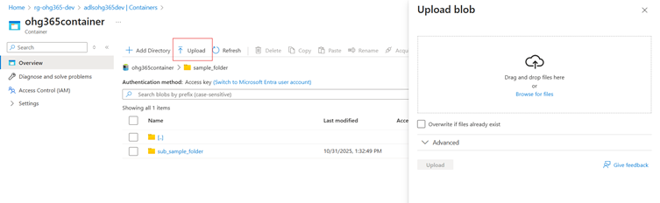
Once you click the Upload option, the Browse for Files page will appear. At the bottom of that page, select the Advanced dropdown option.

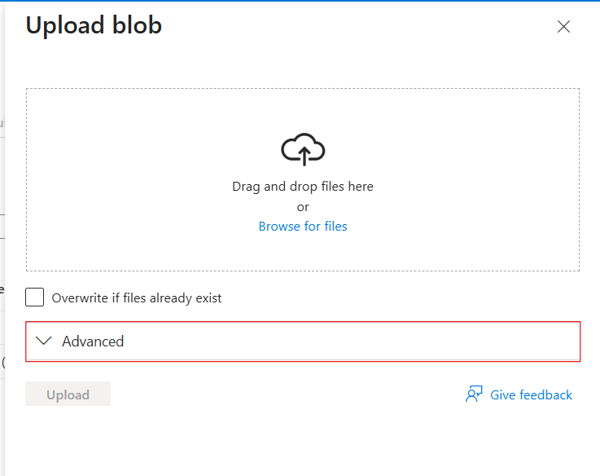

After clicking the Advanced option, the Access Tiers section will appear. Click on it to view all access tier types, and then select one.

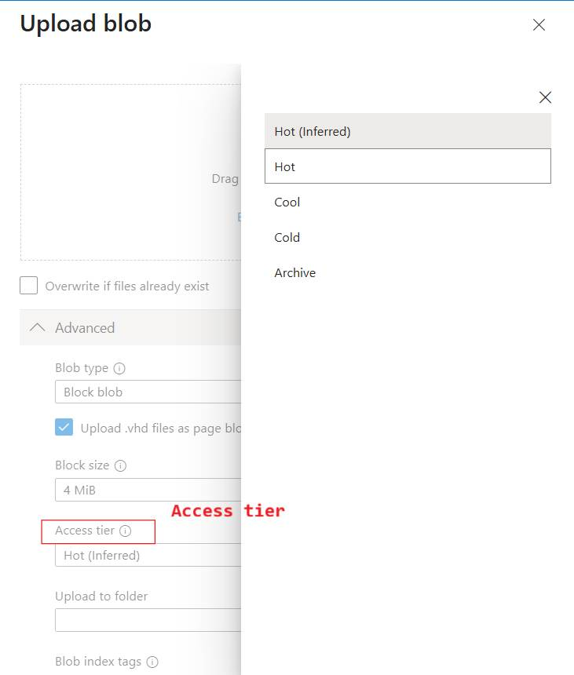

After selecting the access tier, the file will be uploaded to the Overview page.

